***Dt : 22/8/2022***

***\*imp***

***Reading input to Java Programs:***

***=>we use Pre-defined class or Built-in class 'Scanner' from***

***java.util package to read the data to JavaPrograms.***

***=>The following are some important methods methods from***

***'Scanner' class:***

***1.nextByte()***

***2.nextShort()***

***3.nextInt()***

***4.nextLong()***

***5.nextFloat()***

***6.nextDouble()***

***7.nextBoolean()***

***8.nextLine()***

***=>All these methods are instance methods and will get the memory***

***within 'Scanner class object' and canbe accessed with object***

***name.***

***=>syntax of creating object for Scanner class:***

***Scanner s = new Scanner(System.in);***

***=>'System.in' in Java represent connecting OS-Buffer to Scanner***

***class Object.***

***Diagram:***

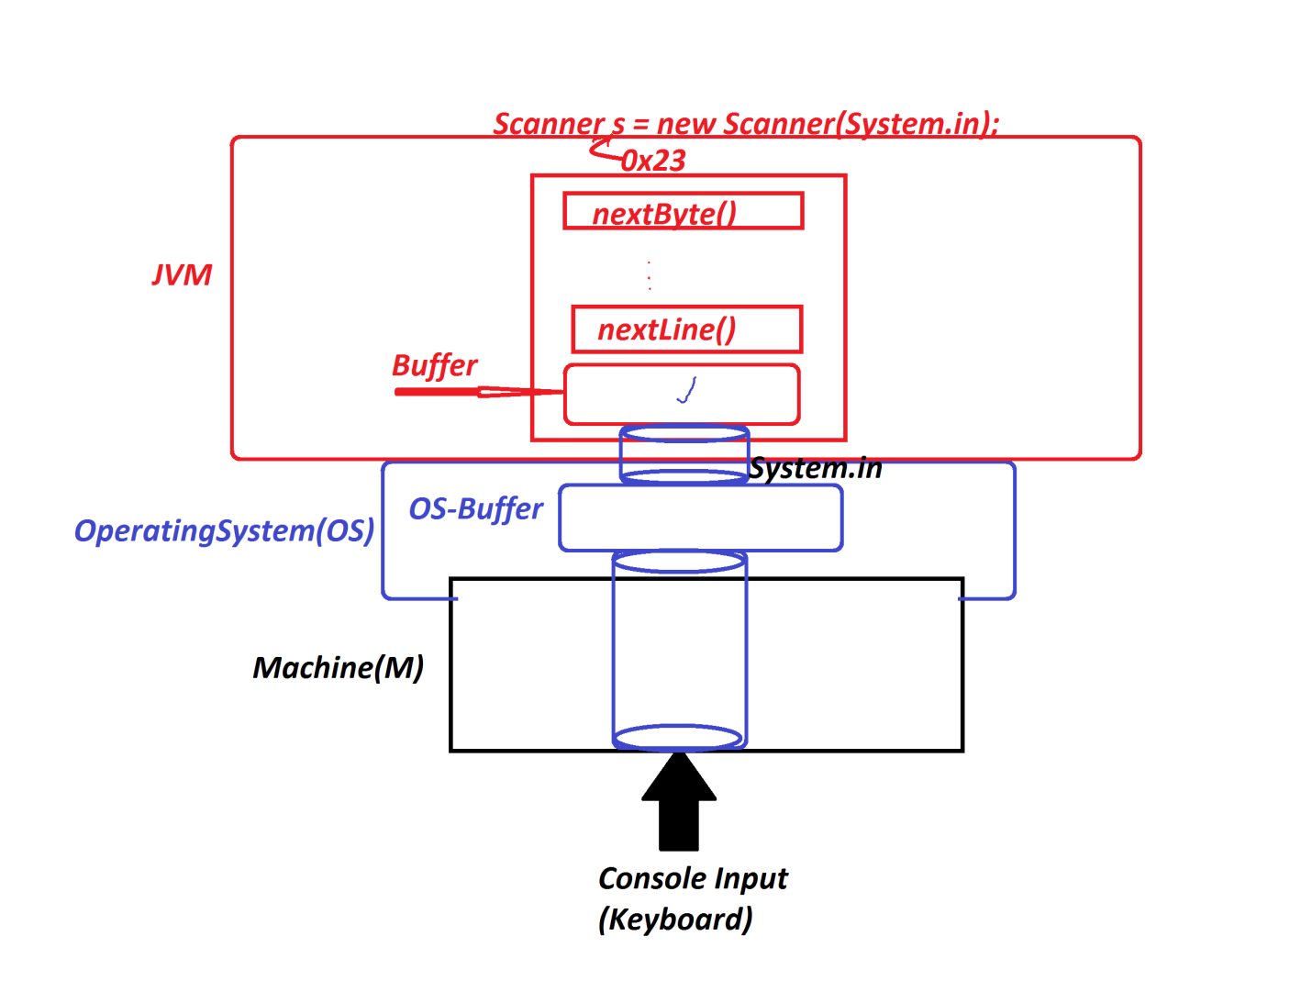

***---------------------------------------------------***

***Syntax of following methods:***

***1.nextByte() : This method is used to read byte data.***

***Method Signature:***

***public byte nextByte();***

***syntax:***

***byte val = s.nextByte();***

***2.nextShort() : This method is used to read short data***

***Method Signature:***

***public short nextShort();***

***syntax:***

***short val = s.nextShort();***

***3.nextInt() : This method is used to read int data***

***Method Signature:***

***public int nextInt();***

***syntax:***

***int val = s.nextInt();***

***4.nextLong() : This method is used to read long data***

***Method Signature:***

***public long nextLong();***

***syntax:***

***long val = s.nextLong();***

***5.nextFloat() : This method is used to read float data***

***Method Signature:***

***public float nextFloat();***

***syntax:***

***float val = s.nextFloat();***

***6.nextDouble() : This method is used to read double data***

***Method Signature:***

***public double nextDouble();***

***syntax:***

***dlouble val = s.nextDouble();***

***7.nextBoolean() : This method is used to read boolean data***

***Method Signature:***

***public boolean nextBoolean();***

***syntax:***

***boolean val = s.nextBoolean();***

***8.nextLine() : This method is used to read String data***

***Method Signature:***

***public String nextLine();***

***syntax:***

***String val = s.nextLine();***

***=======================================================***

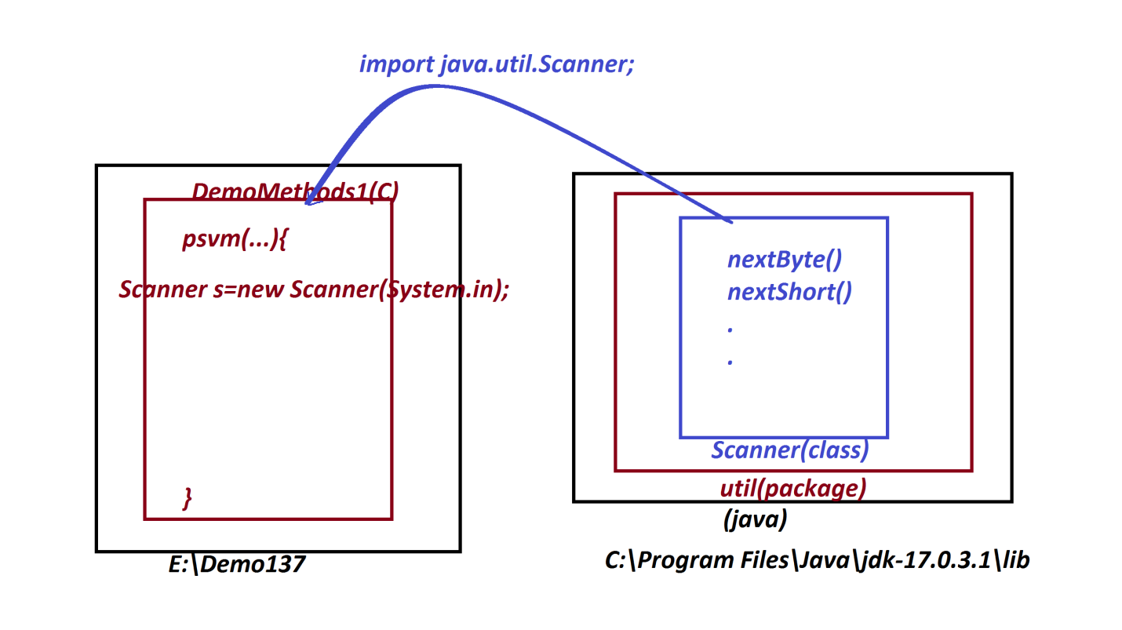

***Ex-Program:***

***wap to read and display UserDetails(userName,mailId and phoneNo).***

***import java.util.Scanner;***

***class DemoMethods1***

***{***

***public static void main(String[] args)***

***{***

***Scanner s = new Scanner(System.in);***

***System.out.println("Enter the UserName:");***

***String name = s.nextLine();//reading String data***

***System.out.println("Enter the MailId:");***

***String mailId = s.nextLine();***

***System.out.println("Enter the PhoneNo:");***

***long phNo = s.nextLong();***

***System.out.println("====UserDetails====");***

***System.out.println("UserName="+name);***

***System.out.println("MailId="+mailId);***

***System.out.println("PhoneNo="+phNo);***

***}***

***}***

***o/p:***

***Enter the UserName:***

***Raj Kumar***

***Enter the MailId:***

***raj@gmail.com***

***Enter the PhoneNo:***

***9898981234***

***====UserDetails====***

***UserName=Raj Kumar***

***MailId=raj@gmail.com***

***PhoneNo=9898981234***

***==========================================================***

***Assignment-1:***

***wap to read and display Product details(pcode,pname,pprice,pqty)***

***Assignment-2:***

***wap to read and display Book Details(bcode,bname,bauthor,bprice,***

***bqty)***

***===========================================================***